Margaret Ann (Weatherhead) Stonerock
June 21, 1871 – June 17, 1969

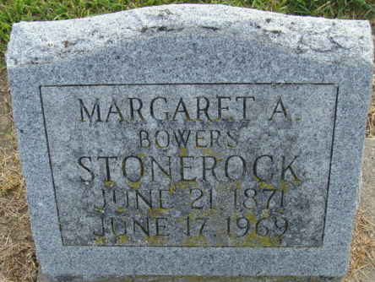
Photo by Alicia Kneuss

Margaret Stonerock Dies Last Evening

Mrs. Margaret Ann Stonerock, 97, of 348 Winchester Street, died at 6 p.m. Tuesday at the Berne Nursing Home following an extended illness. She was born at New Lisbon, Henry County, June 21, 1871, a daughter of Mr. and Mrs. Weatherhead. She was first married in 1905 to Tracey A. Bowers, who preceded her in death. She was later married in 1921 to William Stonerock, who is also deceased.
Mrs. Stonerock was a member of the First United Methodist Church.
Surviving are two daughters, Mrs. Alma Colter of Decatur, with whom Mrs. Stonerock made her home, and Mrs. Lawrence (Katherine) Cowen of San Rafael, Calif.; one son, John S. Bowers of Fort Wayne; and 13 grandchildren. One daughter, Vera, two sisters and one brother are deceased.
Funeral services will be conducted at 2 p.m. Friday at the Winteregg-Linn Funeral Home, with Rev. Melvin Seeger officiating. Burial will be in the Decatur Cemetery. Friends may call at the funeral home from 2 p.m. Thursday until 1:30 p.m. Friday. The casket will be closed prior to the service.

Decatur Daily Democrat, Adams County, Indiana
Wednesday, June 18, 1969

**
Indiana, U.S., Death Certificates, 1899-2017
Name Margaret A Stonerock
Gender Female; Race White
Marital Status Widowed
Age 97
Birth Date 21 Jun 1871
Birth Place Indiana
Death Date 17 Jun 1969
Death Place Berne, Adams, Indiana, USA
Parents Unknown
Informant Mrs. Alma Colter; daughter; Decatur, Indiana
Burial June 20, 1969; Decatur Cemetery; Decatur, Indiana

